Name:- Abdul Ahad Khan

Topic:- Tasks lists 1

* Part 1

a. Represent the data, which includes the total count of account numbers against the country, in a tabular format.

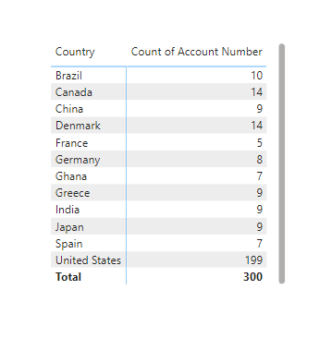

b. Insert another table and represent the data on the country-wise Account holder's name.

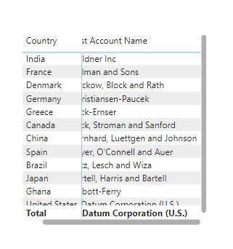

c. Insert a slicer from the visualisation section and add a country-wise filter.

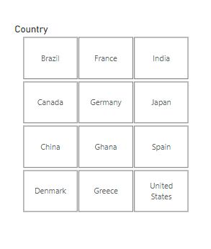

d. Represent the data of India, Brazil, Greece, and France together.

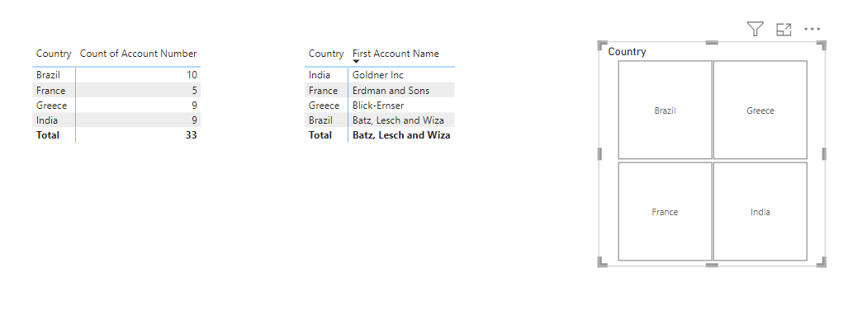

* Part 2

1. Represent the data as per the given criteria:

a. Country-wise industry and average profitability margin (in Percentage %)

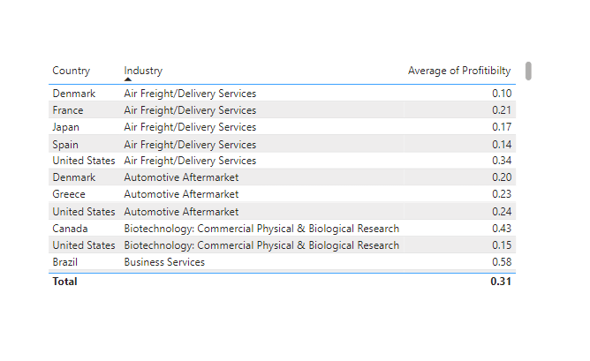

b. Add a separate filter so that country-wise industry and profitability margins can be shown based on the selective countries (There is no bar on country selection).

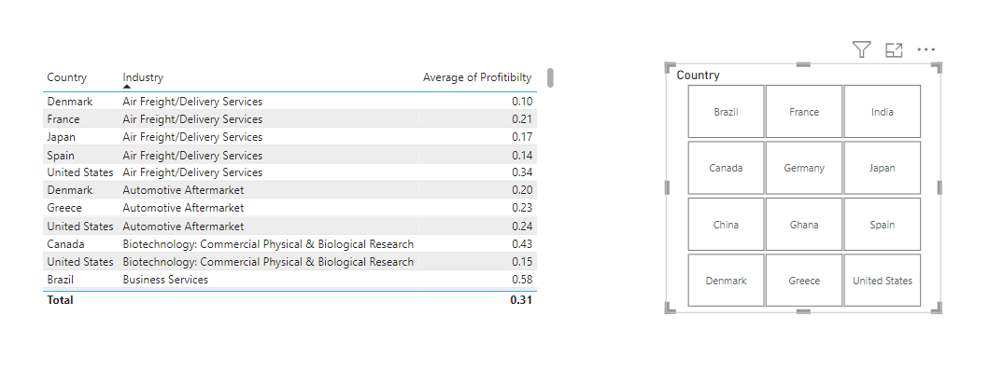

2. Represent the following data using a pie chart:

a. Industry-wise profitability percentage

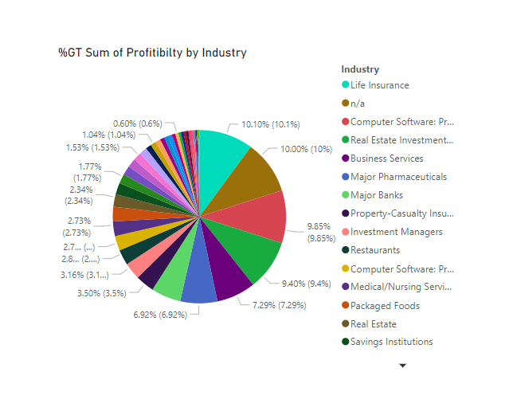

b. The data should be visualised in single or multiple country-wise

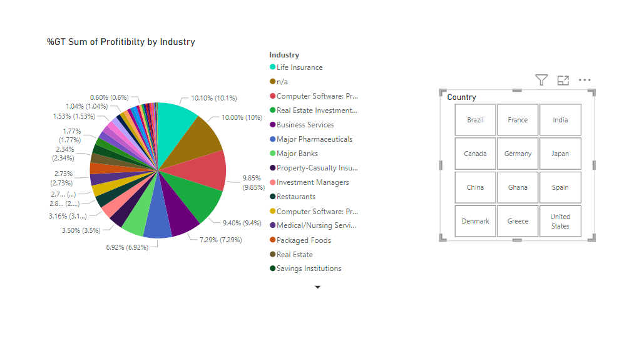

3. Present the data that shows industry-wise profitability trends by taking the Line & stacked column chart from the visualisation section.

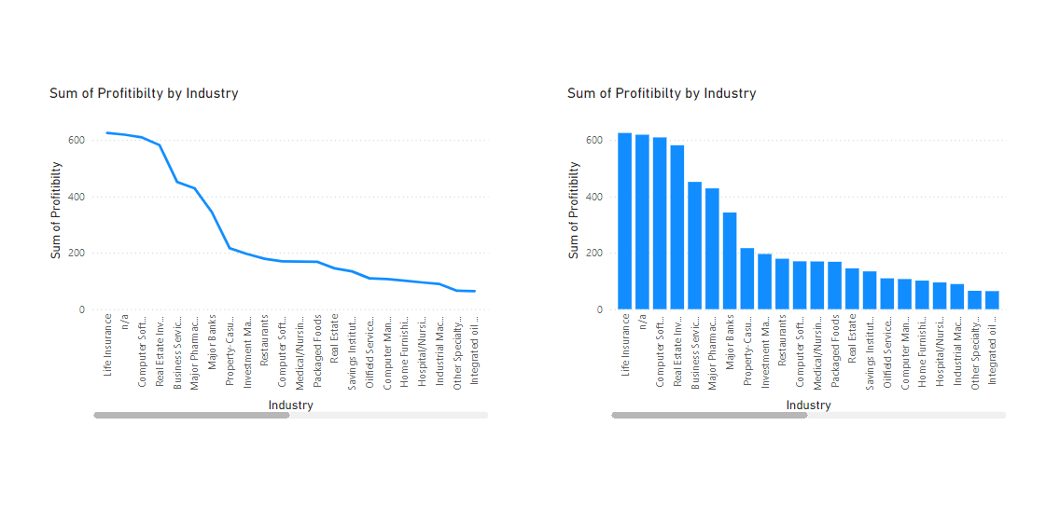

4. Present the data to show country-wise industry market values and industrywise presence by taking the map chart.

